Intake Sheet, page 1, Shaded Area
1: No | 2: No | 3: Yes | 4: Yes | 5: Yes
Filing Status - Married Filing Jointly
Federal Refund - $4,717
State Refund - $730

Basic Information
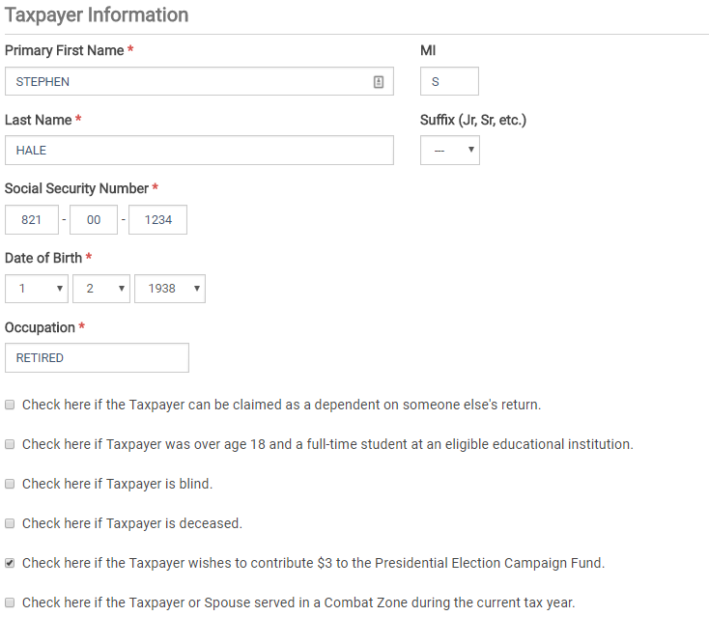

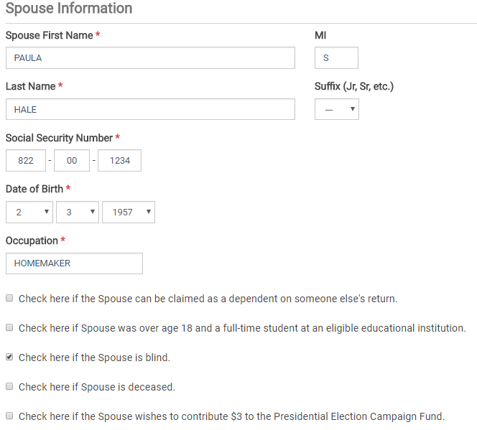

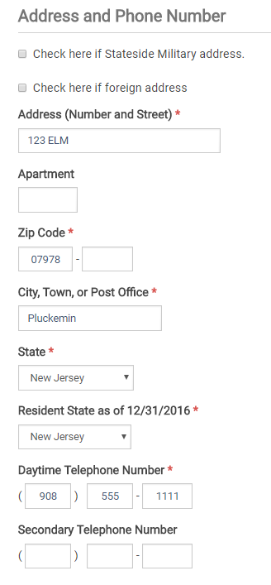

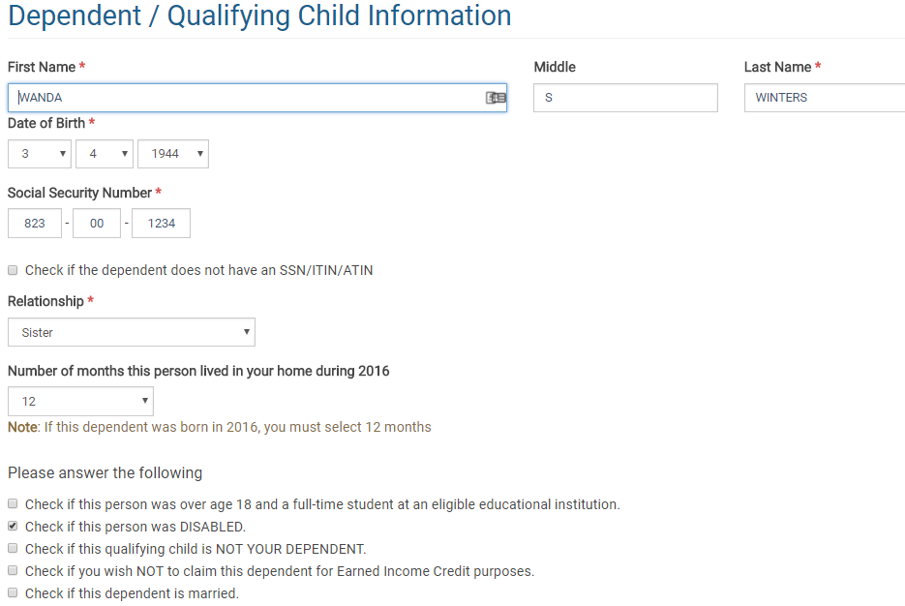
Interest
ACME Brokerage
Taxpayer selected
Box 1 =125
Box 3 = 506
Box 4 = 50
Savings Bond Interest subtracted from NJ = 506

ACME Brokerage Tax Exempt Interest
Taxpayer selected
Interest Income = 338
Taxable New Jersey Amount = 189

Dividends
ACME Brokerage
Taxpayer selected
Box 1a = 232
Box 1b = 125
Box 2a = 69
Box 3 = 32
Box 4 = 80
Box 6 = 44

ACME Brokerage – Tax Exempt Interest Dividends
Federal = 400
Taxable New Jersey Amount = 154

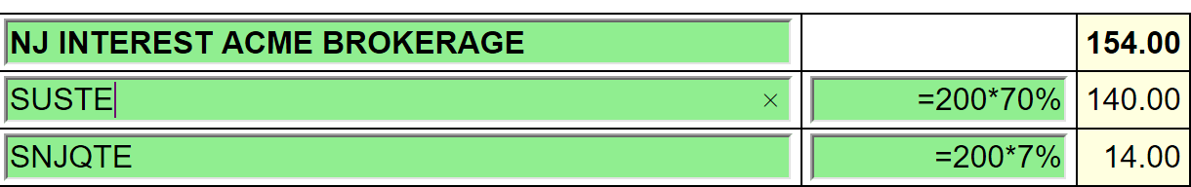
For SUSTE (Not a NJ qualified fund), only the District of Columbia, Puerto Rico and US Possessions
are exempt. 30% is exempt. 70% is taxable.

For SNJQTE (A qualified NJ fund), all the above plus the 70% New Jersey is tax exempt. 93% is
exempt. 7% is taxable.

Private Activity Bond Interest amounts are entered on AMT Form 6251. Use a scratch pad to total all the PABs in the return. If AMT is generated the return is out of scope. See form below.

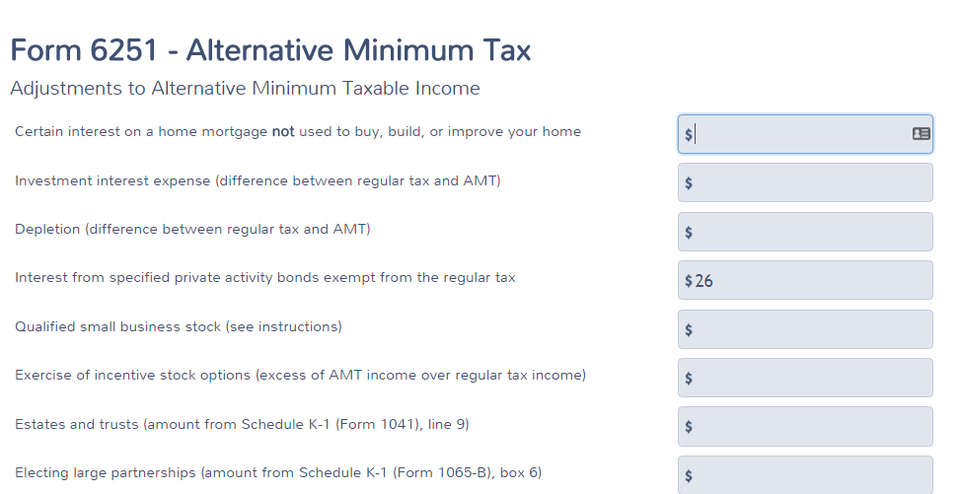

1099-R

ACME Pensions
123 MAIN
PLUCKEMIN, NJ 07978
Stephen Hale checked
Box 1 = 23,793
Box 2a = 23,793
Box 4 = 2,379
Box 7 = 7

OFFICE OF PERSONNEL MANAGEMENT
PO BOX 45
BOYERS, PENNSYLVANIA
Stephen Hale Checked
Box 1 = 18,625
Box 2a = 18,006
Box 4 = 1,862
Box 5 = 2,300 – This amount should be put in Sch A Medical – Insurance
Box 7 = 7
Box 9b = 15,984
Box 12 = 700
Box 13a = New Jersey
Box 14 = 18,006

Difference between Box 1 and Box 2a to be entered on the NJ Checklist

Simplified Rule Worksheet - See Bogart Annuity Calculator Print Out – Best practice is to
use the Bogart Calculator to determine the correct numbers and insert into the TSO
worksheet. If TP or Spouse is a public safety officer, insert the calculated amount from
the Bogart Calculator directly into line 2a of the 1099-R.
    - Plan Cost 15,984
    - Start Date 2/1/2009
    - Check Joint Annuity Box
    - Age of recipient at start date – 122
    - Number of months paid in 2015 – 12
    - Amounts previously recovered – 4281
Taxable amount Box 2a – 18,006

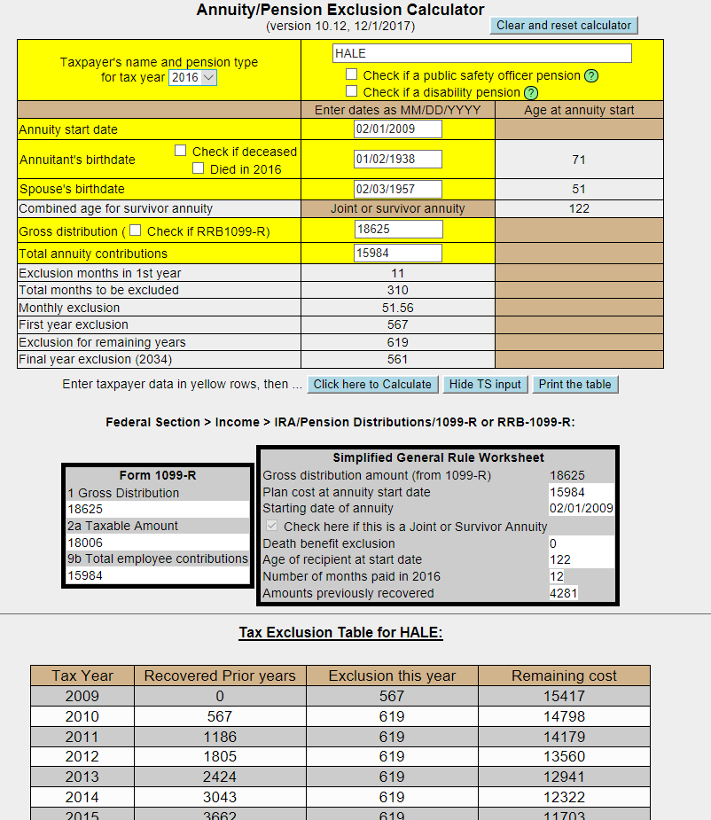

ACME IRAS
123 MAIN
PLUCKEMIN, NJ 07978
Paula Hale checked
Box 1 = 1,000
Box 2 = 1,000
Box 4 = 100
Box 7 = 7
IRA Box Checked

Question 1 – If she took a distribution in June she would not have been 591/2 and would have be
subject to a 10% penalty.

Question 2 – The TP was in a 10% tax bracket. The $100 withholding was the exact amount of the tax
increase.

SSA-1099
Benefit = 15972
Federal Tax Withheld = 550
Medicare Premiums = 2,195

Capital Gains
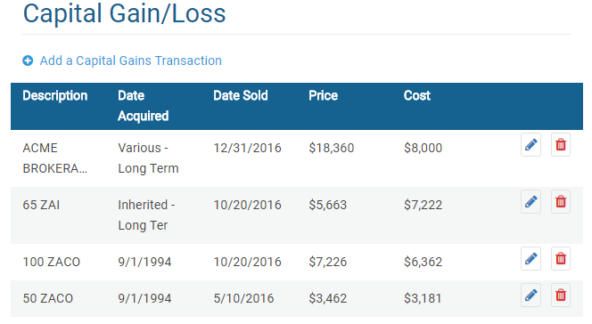
Cost Basis Not Reported
Cost Basis Reported
Cost Basis Not Reported
Cost Basis Not Reported

- ZAI – Check that Wash sale was entered @$97
  - Adjustment description = “Nondeductible loss from wash sale”

- ACME Brokerage – Consolidated entry –
  - Description – ACME Brokerage
  - Date Acquired – Alternate Option – Various Long Term
  - Date Sold – Use latest date sold
  - Adjustment description = “Reporting Multiple Transactions on a Single Row”

- Other Capital Gains Data – Long Term Carryover = 12,454

K-1

Entity Information
- Be sure Form 1065 was used and Entity Information should be checked as shown below:
- Steven Hale checked
- Acme Partners
- EIN – Includes a number
- 123 Main, Pluckemin, NJ 07978

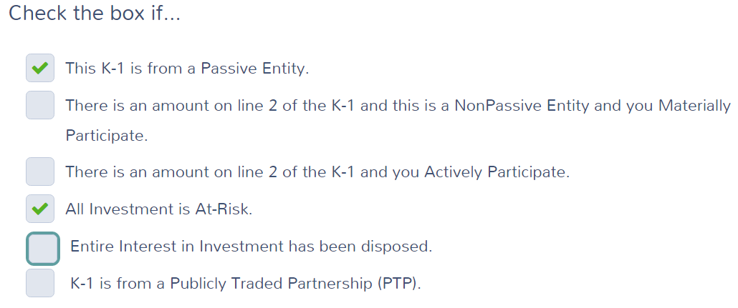
Income

Box 6a = 474
Box 6b = 101
Box 7 = 976
Box 8 = 72
Box 9a = 218
Box 18A = 31

Gambling Winnings
- For Paula
- EIN – Includes a number
- New Jersey Lottery
- PO Box 41, Trenton, NJ 08625
- Winnings = 10,000
- Federal Tax Withheld = 2,000
- Type of wager = Lottery
- Date Won = 7/15/2016

Log total gambling winnings in the NJ checklist

Gambling losses should be entered on Sch A

Estimated Tax Payments
State Estimated Payments
4/15 = 60
6/15 = 60
9/15 = 60
12/31 = 70
Note: The $50 NJ estimated payment made on 1/3/2015 for TY 2014 is not entered here. See Itemized deductions – Taxes You Paid.

Itemized Deductions

- Taxes You Paid
1. 203 paid for last year’s taxes plus
2. 42 paid for taxes owed from three years ago

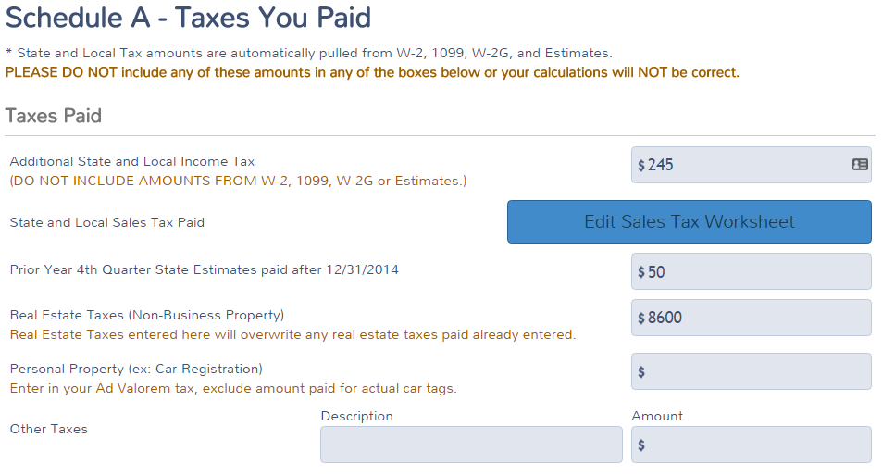
Estimated tax payments to NJ made on 1-3-16 for TY2015.
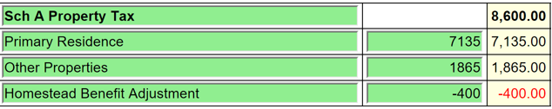

Sales Tax Worksheet
  - Enter NJ and 366 days and Zip 07978

- Medical
  - Medical Insurance

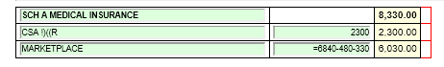

  - Doctors = 300

  - Long term care
    - Be sure Paula is selected from the drop-down menu for long term care insurance
      - Amount = 1,800 (Amount on Sch A reduced due to limitation based on age)
- Mortgage Interest
  - Mortgage Interest Reported on Form 1098
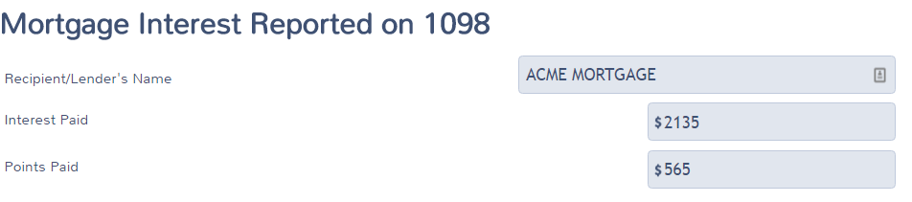
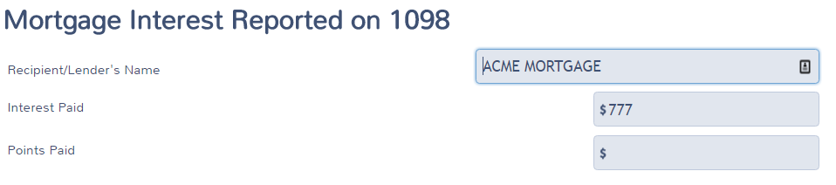

  - Primary Mortgage Insurance (PMI) Deduction
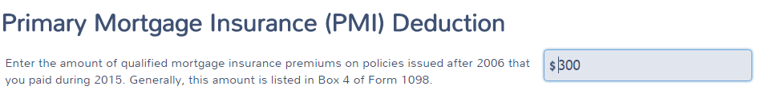

- Gifts to Charity
  - Cash = 600

- Misc. Deductions
  - Gambling Losses
    - Gambling Losses = 10,000. Cannot exceed winnings.

- Health Insurance
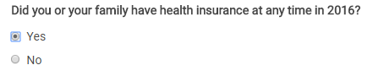

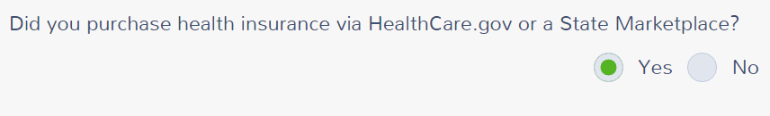

Verify your Household Members – CONTINUE

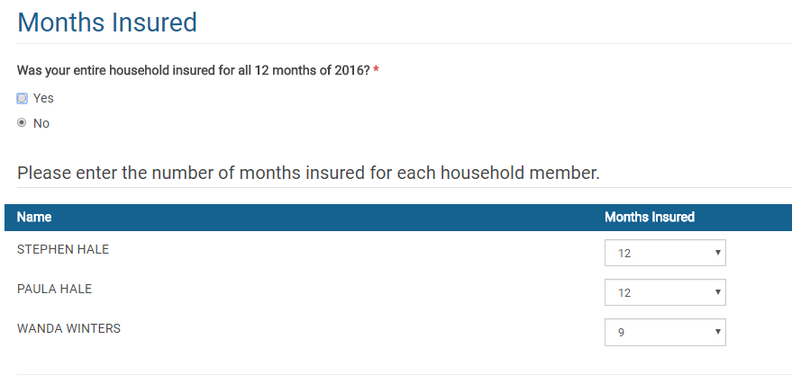

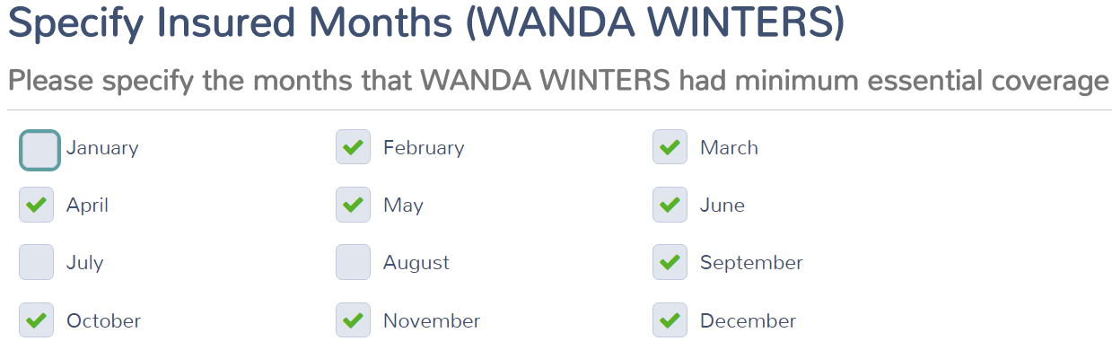

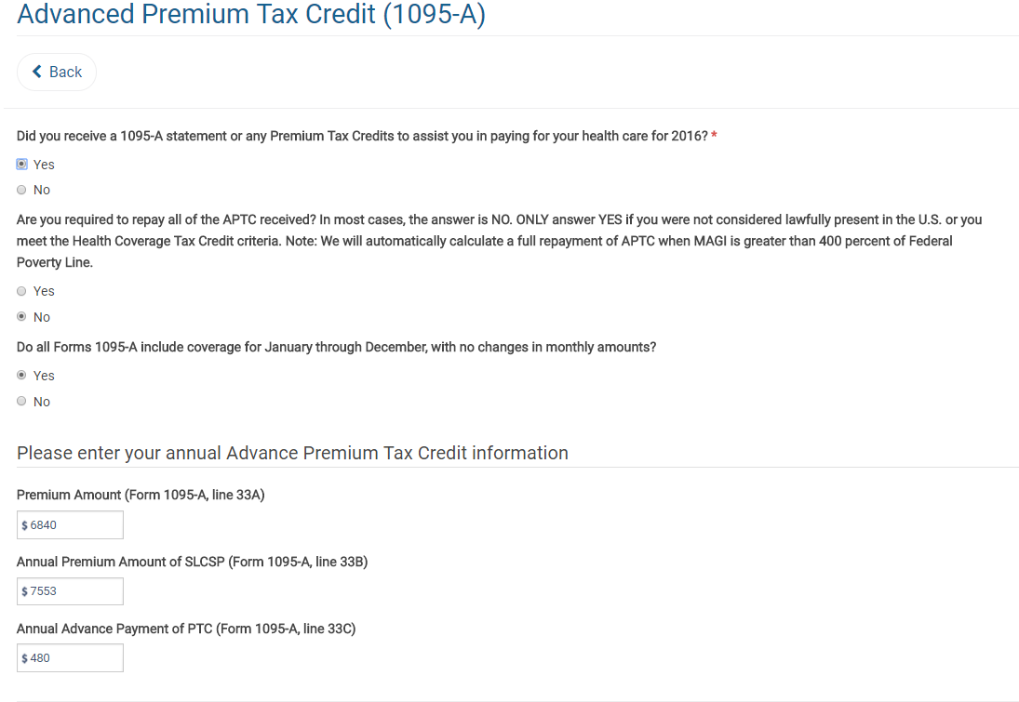

Dependents' Modified AGI (if filing requirement) - None – CONTINUE

Do you qualify for Health Care Exemptions? Continue on the first screen.

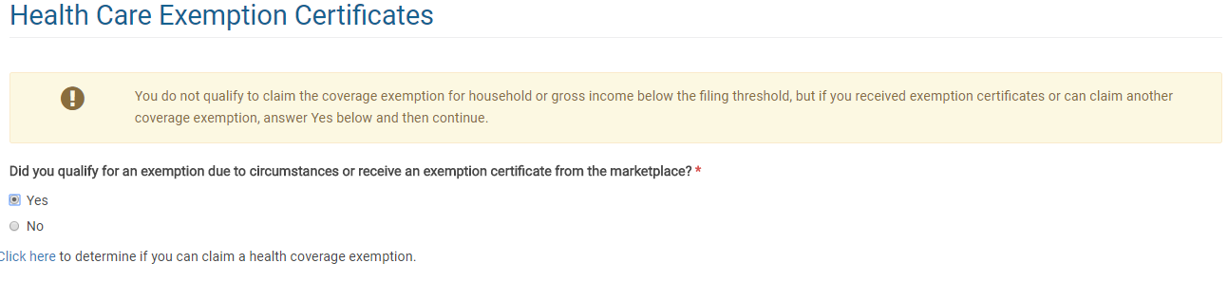

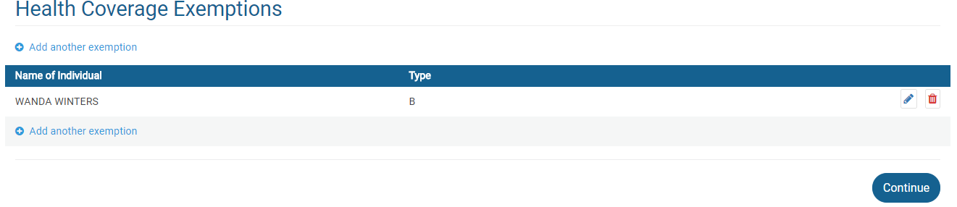

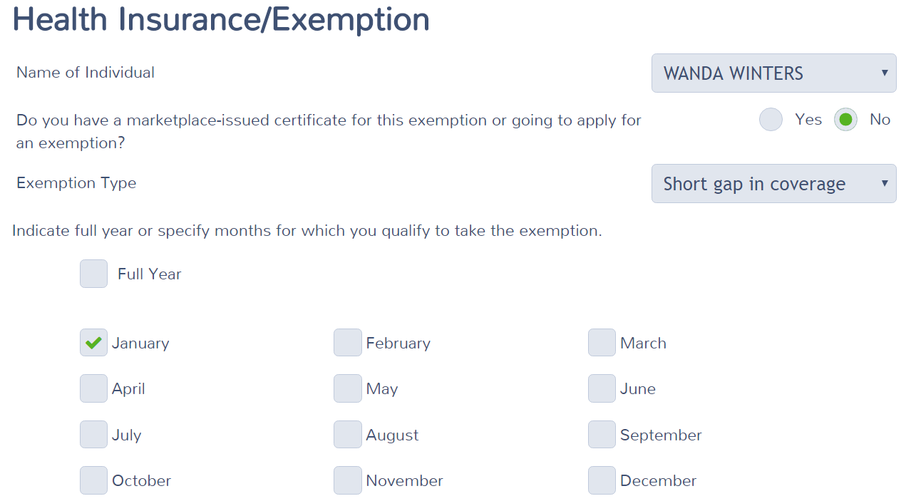

Medical Insurance Deduction for Marketplace coverage

New Jersey Return

Check that the numbers shown in the NJ Checklist below have been properly entered in to TaxSlayer.

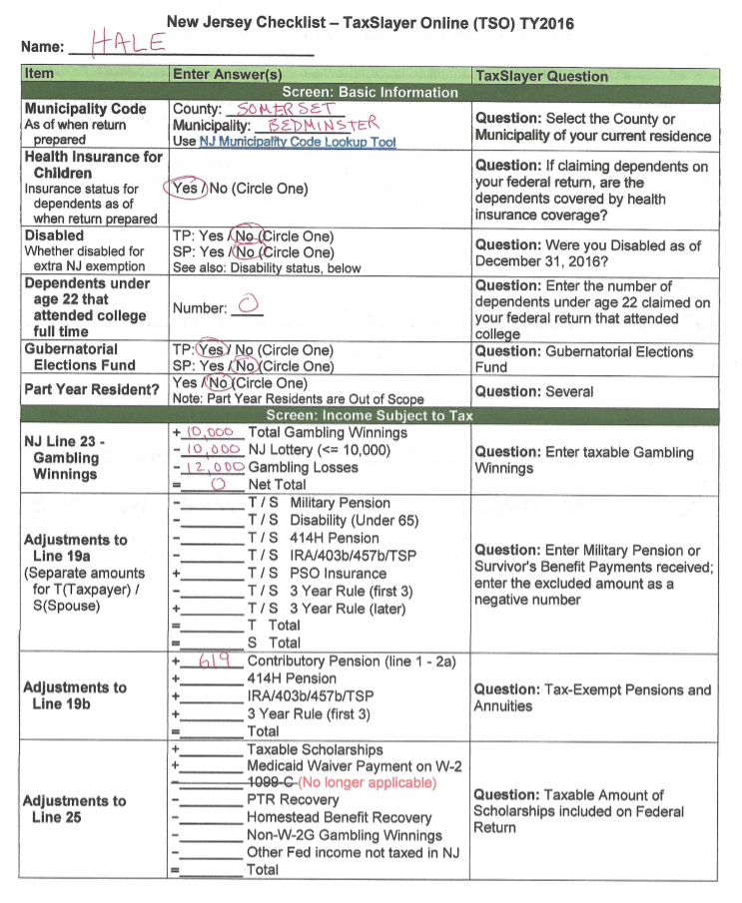

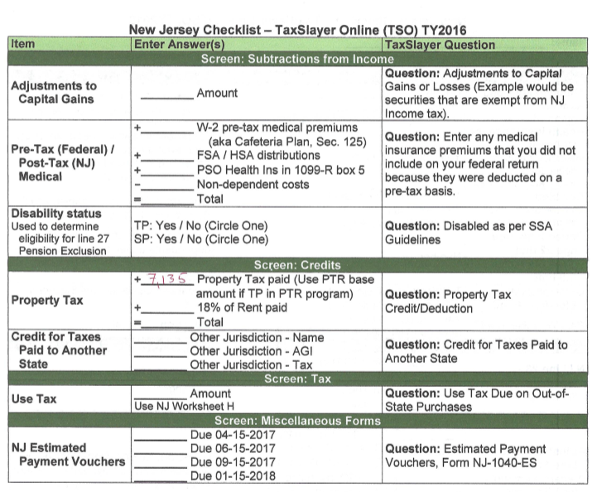

Note : Property Tax Credit. Did you meet Property Tax Eligibility requirements?
Where you a homeowner in 2016?
Yes, to both questions.
Block – 50001
LOT – 00002

E-fILE
K-1 error – Ignore for now
Federal return type – E-file: Direct Deposit
Primary Client Email – sandphale@mail.com
State refund type – Not Selected (Due to K-1 problem)
Bank Account In formation
Account Type: Checking
Deposit Amount: 4,717
Routing Number: 081904808
Account Number: 986532
Consent Disclosure – Check complete with either answer and Pin entered
Questions - Answered

